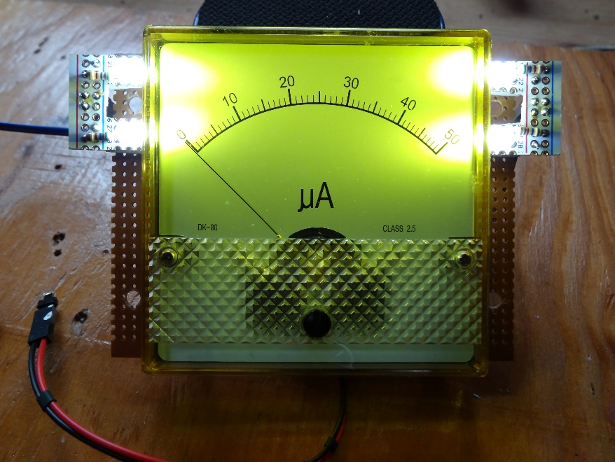

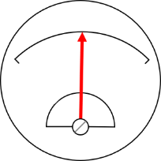Analog Meter Fundamentals

Jan Goolsbey, Cedar Grove Studios

November 2018

# Analog Meter Fundamentals

Analog meters have a wonderful retro look and are easy to read with a glance. Can you make one work with your project? With one of these meters, you’ll be able to display either voltage or current of almost any range or value with some simple components. Ohm’s Law will become your analog friend.

## Overview

To learn more about analog meters:

<https://en.wikipedia.org/wiki/Galvanometer>

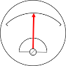Analog meters used to be an excellent and sometimes the only way to display electronic circuit activity. They are round, square, rectangular, lighted, mirrored, small and large, slow and fast. They have been used to measure voltage, current, power, resistance, radio frequency (RF) fields, engine RPMs, audio volume units (VU), and just about anything else. The meter’s lightweight needle darts above a printed scale, eventually settling to point at the measured value.

Analog meters are closely related to galvanometers and motors. Common analog meters are built with magnets, a small coil of wire, jewel pivot bearings, fragile pointers, and a miniature spring (like the balance wheel hairspring in a mechanical timepiece), all sealed in a wind-tight case with a clear cover. With the proper components attached, these meters can measure signal levels as sensitive as millivolts and microamperes all the way to kilovolts and tens of Amperes. Changing the displayed scale is as easy as printing and attaching a new scale legend.

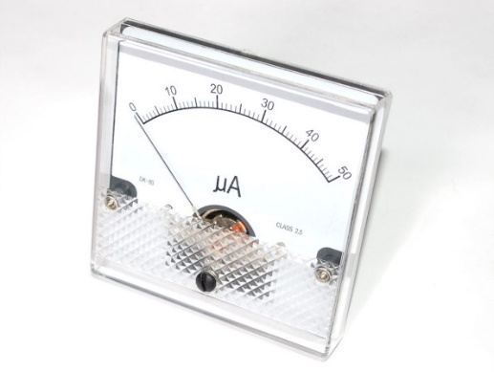

Adafruit’s Analog Panel Meter

Although not widely in use as of this writing, analog meters are still available to purchase. Many meters can be reclaimed from old equipment and repurposed. An analog meter can add retro elegance to a modern project. Would one work with yours?

For the examples in this guide, we’ll be using a 50-microampere analog panel meter from Adafruit ([PID # 252](https://www.adafruit.com/product/252)).

## Meter Electromechanics

Common analog meters consist of a moving wire coil suspended in a magnetic field created by a stationary core and surrounding permanent magnets. The coil is suspended on jeweled bearings with tension provided by one or two spiral wound springs that return the coil to a resting position when no current is applied. As current is applied to the coil, it deflects the attached indicator needle linearly in proportion to the amount of current flowing through the coil.

When no current is flowing through the meter, the indicator needle will rest at the zero point, usually on the left of the scale, sometimes in the center. If connected correctly, the needle will deflect towards the full-scale position in proportion to the current flowing through the meter. If the connection is reversed, the needle will move to a value less than the resting (zero) position. Reverse deflection below the limit of the scale can damage the sensitive and fragile coil assembly and should be avoided. Similarly, if too much current is applied, the coil will move beyond the full-scale value and cause similar damage to the coil assembly. The slang phrase for pushing a meter beyond its physical limits until the needle hits a mechanical stop is called “pegging the meter.”

Moving-coil meters respond to direct-current (DC) flow. Most commercially available meters respond to current levels as low as 25 microamperes and up to 10 milliamperes full-scale. With some simple external components and Ohm’s Law, analog meters can be employed to display kilovolts and deca-amperes.

Using a meter for displaying a current level is simple: connect it in series between a power source and a load then read the value on the scale. The meter’s needle will point to a value as accurate as the meter can measure in its range, usually within 1% to 5% of the full-scale value. A resistor added across the meter’s terminals can be used to extend the current measurement range of the meter.

If it’s voltage that you want to measure with the analog meter, select and place a resistor in series with one of the meter’s terminals. The voltage range can be adjusted to a wide range by modifying the value of the series resistor.

We’ll need to know a couple of things about the meter to proceed, its full-scale current value (likely printed on the meter or accompanying documentation) and the voltage drop measured across the meter when the needle is deflected to full-scale. If you don’t know your meter’s full-scale current value or voltage drop, then briefly skip to section *3. Characterize the Meter* to discover those values. You will need both in order to adapt the meter to measure a variety of full-scale voltage and current levels.

## Measure Current

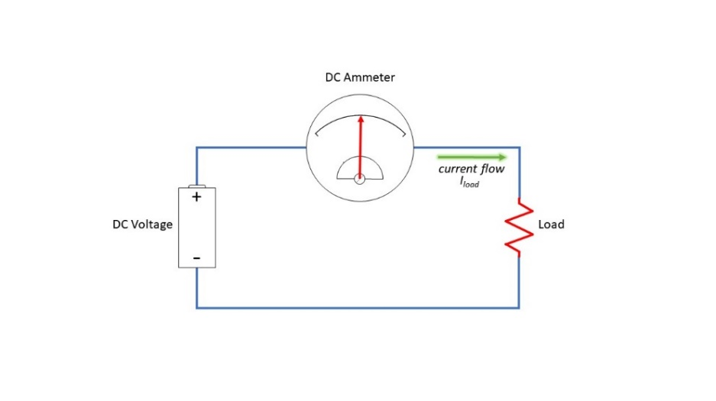Measuring current is natural for most moving-coil analog meters. The meter’s primary mode of operation is to measure the amount of current passing through its coil. To use a meter to measure the current flow of a circuit, select a meter with a full-scale value that is greater than the maximum current expected. Place the meter in series with the power source and the circuit under test (the “load”) to measure the amount of current the circuit is drawing from the power source.

Most meters are very sensitive and can only measure a small amount of current at full-scale. For example, our 50-microampere (uA) meter is too sensitive to measure the current through a typical light-emitting-diode (LED) since an LED will draw 5 to 20 milliamperes (mA). That’s at least 100 times the current the meter can handle and will certainly damage the meter! (Remember what happens when the needle goes past full-scale?) If you’re planning to measure higher values of current than the meter’s rated range, we’ll need to make a couple of calculations using Ohm’s Law.

### More Current (Introducing the Shunt Resistor)

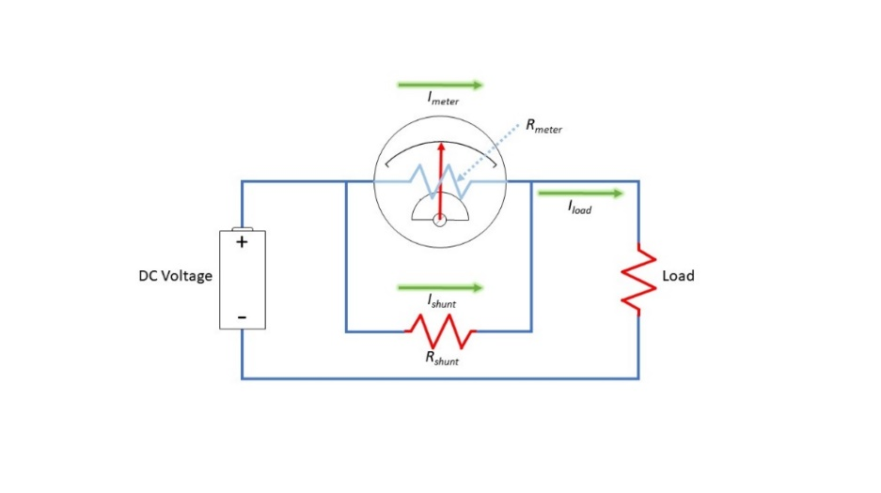A resistor placed in parallel with the meter can be used to pass most of the circuit’s current around the meter while still allowing a smaller amount of current -- proportional to the total current – to pass through the meter. In effect, the parallel resistor shunts current that could damage the meter directly into the load. Here’s how it works.

The entire current to the load passes through both the meter and the shunt resistor. Because of differences between the meter’s internal resistance (Rmeter) and that of the shunt resistor (Rshunt), the meter will see a just fraction of the total current. That fraction is directly proportional to the ratio of the meter and shunt resistance values. If the load requires 50mA and if the meter can only indicate a maximum of 50uA (0.05mA), the shunt resistor will need to divert 49.95mA away from the meter.

Since the voltage across the shunt resistor is the same as the meter voltage, it’s easy to calculate the value of the shunt resistor. Here’s the formula:

Vmeter = 92.2mV = 0.0922V

Iload = 50mA = 0.050A

Imeter = 50uA = 0.00005A

Substitute these values and solve:

To bypass the current not used by the meter, our shunt resistor will need to have a value of 1.85 ohms.

We’ll need one more calculation to determine how much heat the shunt resistor will need to dissipate when the circuit draws the maximum of 50mA. For many electronic devices, heat dissipation is measured in Watts. Resistors with a higher wattage value can safely dissipate more heat than those of a low wattage. Shunt resistor heat dissipation is a very important number to know when measuring current; if exceeded, damage may occur.

The formula for determining wattage is:

Substituting the voltage across the shunt resistor (0.0922V) and its current (0.04995A) tells us that the shunt resistor will need to be sized to dissipate 4.6mW, well below a typical resistor’s 128mW (1/8W) maximum dissipation value.

DigiKey stocks a 1.82-ohm resistor with a resistance value close enough to work in this example given the +/-3% accuracy of the 50uA meter. This resistor’s specified 250mW dissipation value is more than adequate, as well.

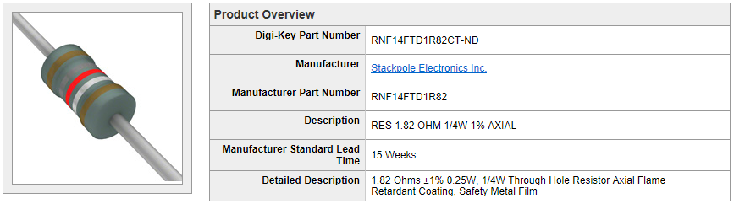

In summary, measuring current greater than the meter’s full-scale value is just a simple matter of understanding the maximum load current to be measured, the meter’s full-scale current value, and the meter voltage when the needle is at full-scale. Throw Ohm’s Law and a power formula into the mix and you can adjust the meter to measure almost any DC current value.

The printed scale may not match the new full-scale value. If that’s the case, look at the section, *2. Print a New Scale*.

Now that we can measure various current values using an analog meter, it’s time to move on to measuring voltage.

## Measure Voltage

A sensitive analog ammeter is capable of measuring voltage with the addition of a single series resistor. The resistor is used to limit the current traveling to the meter so that the meter can proportionally respond to the measured voltage value.

In this diagram, we’re measuring the voltage across a load that’s supplied by a battery. The battery’s DC voltage provides a current through the series resistor (Rseries) and the meter that is in proportion to the resistance of Rseries. For example, let’s assume that we’re using our friendly Adafruit 50uA meter and the battery is supposed to provide at least 12 volts. Let’s calculate the value of Rseries that will result in full-scale needle deflection if the voltage reaches 50 volts.

Vfullscale = 50V

Imeter = 50uA = 0.000050A

Vmeter = 92.2mV = 0.0922V

Substitute these values and solve:

The closest value in DigiKey’s stock is 1M ohms. That value will introduce an error of only 0.2%, well within the meter’s accuracy.

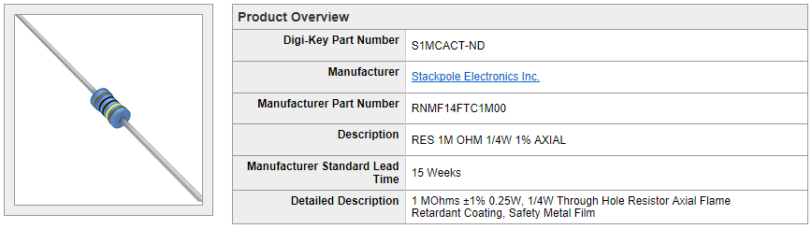

Let’s try one more example. We would like the full-scale voltage value to be 3.3 volts, the maximum voltage used by many microcontrollers.

We’ll select a resistor as close to that as possible. DigiKey stocks resistors with values of 63.4K and 64.9K ohms. We’ll pick the closest one, 64.9K ohms. The error introduced by the resistor selection is just 1.2%, sufficient for most projects.

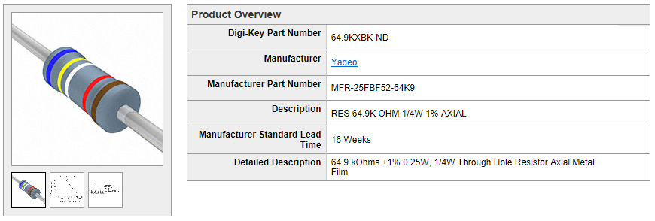

Okay, but the meter’s scale is shown as 0 to 50uA. The printed scale does not match the new full-scale value of 3.3 volts. The next section, *2. Print a New Scale*, will help with that.

# Print a New Scale

So, the 0 to 50 uA meter scale doesn’t represent the values you plan to measure? A new label can be made from a sheet of paper and a protractor. It can be drawn by hand or using your favorite software drawing, CAD, or photo tool. The process is pretty much the same regardless of the media or tool.

Most analog meter scales can be matched to a degree spread on a protractor. In the case of the Adafruit 50uA meter, the needle travels along 90 degrees of a circular arc with a radius of 4cm. Laying that out using a protractor or on an image of a protractor is the first step. After that, you can add the graduations and the legend as required. If the scale you need is linear, that’s easy. A logarithmic scale will probably take longer and will require some planning and patience. If you’re making a weather gauge, then you may only need three colorful symbols (stickers?) for sunny, cloudy, and precipitation such as an image of the warm sun, a menacing cloud, and when it’s raining cats and dogs. Use your imagination!

Once designed, print a draft version to make certain it will fit. For most meters, cut the paper scale to a rectangle the size of the visible window. After removing the meter’s clear cover, place the new scale over the old scale and under the needle. Try not to bump the needle or meter movement – it’s easy to throw the sensitive parts out of alignment. If the draft scale fits correctly, print the final scale on photographic paper, otherwise continue to work the dimensions until the draft scale fits. Secure the new scale with two or three dots of glue from a glue stick or use three pieces of clear tape along the top and sides. If you use tape, keep the overlap on the face of the scale as small as possible so the tape won’t be visible.

Free-use protractor images and design files can be found on many Internet sites. One of my favorites is Michael Ossmann’s excellent quality *Print a Protractor* site (<http://www.ossmann.com/protractor/>). The files are available for use under a *Creative Commons Attribution 2.5 License*.

# Characterize the Meter

## Find the Meter’s Numbers

If you are repurposing a used meter, it’s likely that the full-scale current range isn’t known. We’ll walk through the process to determine a meter’s range using a stable power source, a few resistors, two potentiometers, and a digital volt meter – providing that the meter movement wasn’t previously damaged, of course.

First, carefully open the case of the meter to confirm that the meter is indeed a moving coil meter (capable of responding to DC current). If you see a fixed coil, it may respond only to voltage or AC current and won’t be useful for anything else than that.

Next, look to see if resistors, copper bars, or other components are attached to the wires coming from the meter coil. If so, carefully remove the components and connect the coil wires to the meter terminals, being extra careful not to disturb the meter movement or needle. Close the meter case when finished removing components. The meter should now respond to a DC current input.

Since most meters will have a manufacturer’s name and model number, search the Internet for information about the meter. The range of the meter and voltage drop may be easy to find from a reliable source like the manufacturer or a commercial supplier. If so, you’re done and can skip the rest of this sub-section. If it looks dubious or you can’t find anything that’s helpful, then you’ll have to measure those values yourself.

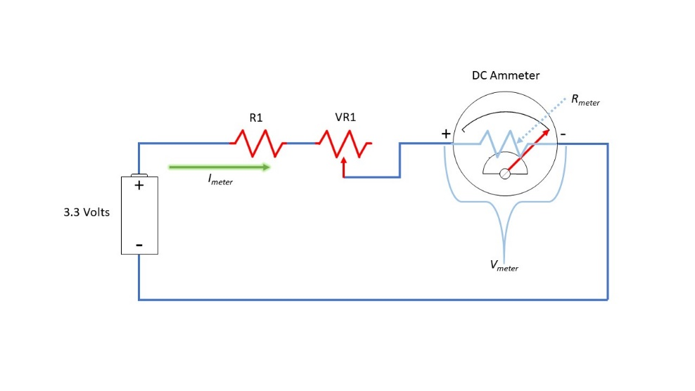The majority of common DC Ammeters have full-scale ranges from 30uA to 10mA. To measure a meter’s range, all we’ll need is a reliable way of generating a measurable current. That’s where the power source and resistors will be needed.

To keep from damaging the meter by applying too much current, we’ll start by applying a current level up to 330uA using a 3.3V-volt power source. Ohm’s Law tells us that to create 330uA of current using a 3.3-volt power source we’ll need a 10,000-ohm (10K-ohm) resistor.

By adding a 100K-ohm potentiometer in series with the 10K-ohm resistor, the circuit will supply a variable current from 30uA to 330uA depending on the position of the potentiometer. When the potentiometer’s resistance is the lowest, the current to the meter will be at the high value, 330uA. When the resistance is highest, the current will be at the lower value of 30uA.

Begin the test with the potentiometer at its highest resistance value, then attach the meter to the circuit. Note the needle deflection, if any. It the needle deflects below zero, then reverse the meter connections and try again. Slowly decrease the potentiometer’s resistance until the needle deflects to full-scale. If it doesn’t reach full-scale, then it’s time to change the resistor and potentiometer to values that can provide more current.

|  |  |  |  |  |
| --- | --- | --- | --- | --- |
| **Test Current Range** | | | **Value of R1** | **Value of VR1** |
| 30uA | to | 330uA | 10K ohms | 100K ohms |
| 300uA | to | 3.3mA | 1K ohms | 10K ohms |
| 327uA | to | 33.0mA | 100 ohms | 10K ohms |

Using the table, start with the resistor combination for the lowest test current range first then work your way up to the highest until the potentiometer can be adjusted to give a full-scale reading. If you still don’t have a needle deflection after using the resistors for the highest range, then there may be a problem with the meter such as an open circuit, damaged coil, or mechanical obstruction.

When the needle reaches full-scale, measure the voltage across the meter terminals using the digital voltmeter set to DC volts. This is the meter voltage drop value. Write it down for future use.

Disconnect the meter and remove the power source. Set the digital voltmeter to resistance mode and measure the total resistance of the fixed resistor plus that of the potentiometer at its current setting (R1 + VR1). Time for the calculator and Ohm’s Law.

The full-scale value of the meter is calculated from the applied voltage (3.3V) and the series resistance value just measured.

Write down the full-scale meter current value. Matter of fact, you may want to scribe it and the meter voltage drop value on the back of the meter case to keep the numbers handy.

## An Example

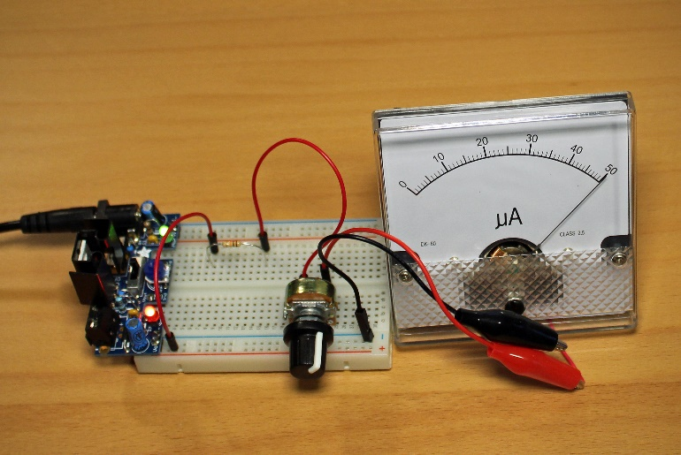Let’s set up the circuit with a 3.3-volt power source to measure the full-scale range and meter voltage drop of our Adafruit 50uA meter. We’ll start with the lowest test current range resistor and potentiometer, 10K-ohms and 100K-ohms. Following the procedure, the potentiometer is adjusted to the full-scale value. For this example, we’ll pretend we don’t know that it’s indicating 50uA.

While the meter is still pointing to full-scale, we’ll attach our digital multimeter to the meter terminals to read the DC voltage drop across the meter. Our multimeter reads 92.2 millivolts (mV). Write that down; we’ll need it soon.

Without changing the potentiometer, disconnect the meter and the power source. We will need to measure the total resistance of R1 and VR1 next. Set the multimeter to resistance measuring mode and place the first probe on the end of the resistor that was connected to the power source. Attach the second probe to the potentiometer pin that was previously connected to the meter.

The multimeter is telling us that the combined resistance that produces a full-scale deflection with a 3.3-volt power source is 63.5K ohms. Make a note of that value and get ready for a quick Ohm’s Law calculation of the meter’s full-scale value.

After the test, we can reliably say that this meter is a 50uA full-scale DC ammeter. We now know the important numbers for our Adafruit meter: It has a full-scale value of 50uA and a meter voltage drop of 92.2mV. Keep track of these numbers for each analog meter in your inventory.

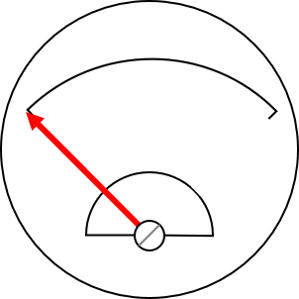

## Understanding the Meter Voltage Drop

Inside the meter is a coil of wire that builds up its own magnetic field causing the needle to deflect. The copper wire used for the coil isn’t a perfect conductor, so the coil will have some resistance. The more sensitive the meter, the higher the coil resistance. Sensitive meters need more turns of wire in the coil to disrupt the field from the permanent magnets in order to be strong enough to move the needle.

According to Ohm’s Law, whenever current flows through resistance, a directly proportional voltage develops across that resistance. The voltage that is created when passing current through the meter at full-scale is called the meter’s voltage drop (Vmeter). Knowing the meter voltage drop will very important as we put external circuity on the meter to increase the meter’s current measuring range or to measure voltage instead of current.

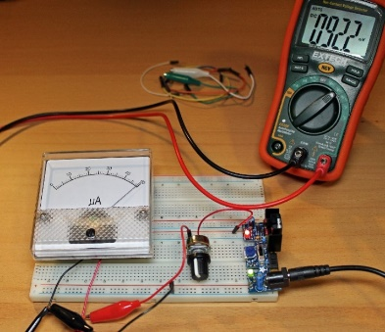For example, a 3.3 voltage source with the 10K resistor plus the 100K-ohm potentiometer used in subsection *3.1 Find the Meter’s Numbers* will provide 50uA through the meter when the total of the resistor plus the potentiometer’s resistance is approximately 66K ohms. The voltage across the terminals of the Adafruit 50uA meter measures about 92.2mV when the meter is pointing to 50uA on the scale.